Girls’ Club

Under the Influence, 2008-09
List of Works

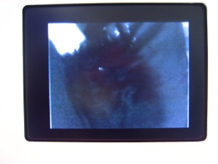
Ann Hamilton
Whitecloth, (Honey Pocket)1999
video, 30 mins. looped

Made using a child’s Pixel Vision camera by Fisher Price, Hamilton’s hand slowly sloshes honey in the pocket of a man’s trousers she is wearing. It is a subtle commentary on erogenous zones and sexual repression. Hands feature prominently in the work of this installation artist, whose often massive multimedia environments immerse the viewer in the repetition of hand labor.

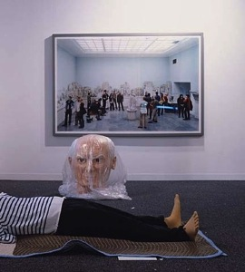
Louise Lawler
Big, 2002-03
cibachrome mounted on museum box, 52” x 46”

Big is from a series of photographs taken by Lawler on location at art fair booths, auction houses, collector’s homes and other sites of art installation. This work depicts artist Maurizio Cattelan's caricature sculpture of Picasso lying decapitated on the floor of an art fair booth; behind it, on the wall, is a Thomas Struth photograph of museum visitors admiring a classical statue, also headless. The photo’s crop of the Picasso figure appears to decapitate the sculpture, and the photo in the background is like a mirror of the viewers taking in Lawler’s work. This type of questioning of the uniqueness of the artwork is characteristic of Lawler’s work.

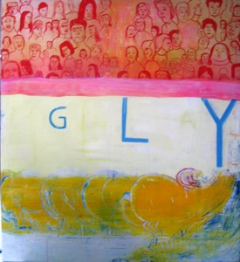
Amy Sillman
Ugly, 2003
oil on canvas, 46” x 42”

Amy Sillman is a New York artist who forges her own distinctive cooperation between abstract, gestural painting and faux naive narrative, complete with doodles and stick figures. A cultivated awkwardness pervades all her work, signaling to the viewer that precariousness and self-doubt are at work, tempered by humor.

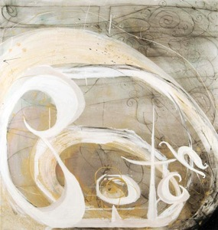
Suzanne McClelland
"Bitch", 2005
Acrylic, oil, and pastel on linen, 51” x 49”

McClelland is an innovator among abstract painters. Sharing Sillman’s obsession with language, she embeds hand-written words into the surfaces of her work. A stunning variety of visual marks jitters across her canvases, as she attempts to “solve” questions of visual and verbal meaning.
Courtesy the artist

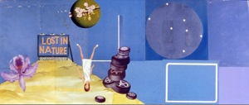
Michelle Weinberg
Botany of Desire, 2005
paper collage, 13” x 33”

Weinberg pieces together found paper images from the stream of books and other printed matter to be found at thrift shops and tag sales. The collages that result are readymade drawings, re-arranging and re-purposing familiar iconography, composing scenes from one long animated film strip.
Courtesy the artist

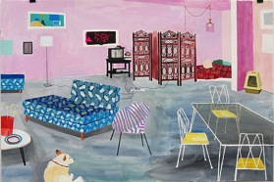
Carolyn Swiszcz
Weinberg Apartment, 2007
acrylic and rubber stamp on paper. 40” X 60”

Swiszcz resides in St. Paul, Minnesota. Her depictions of humble suburban scenes reflect her precise observational acumen. An eye for detail and texture brings her subjects to life. Painted while staying with Michelle Weinberg in Miami Beach, Swiszcz faithfully renders the Weinberg apartment.
Courtesy of artist

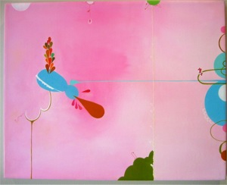
Vickie Pierre
We Were, You and I, (from Allegria), 2004
oil and ink on canvas, 9” x 9”

Vickie Pierre is a Miami artist who creates paintings that combine hidden text messages in swooning, sensual organic forms and color fields.

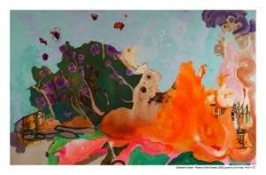
Elisabeth Condon
Realms of the Dynasty, 2007
acrylic on linen, 44” x 72”

Condon is a seasoned world traveler who has absorbed the lessons of traditional Chinese painting and set them on fire with her own vivid references to natural and man-made forms. She cites Dr. Seuss as a major influence.

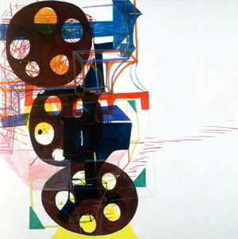
Joanne Greenbaum
Portrait, 2003
oil and flasche on canvas, 60” x 60”

Greenbaum’s abstractions are carefree responses to the sanctity and legacy of grid-based painting. Her off-balance compositions of blunt forms in bold, crayon colors suggest the solidity of architectural structures, but also the unpredictability of games of chance.

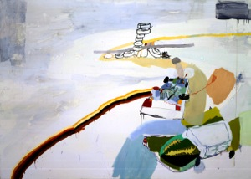
Lisa Sanditz
The Gloomy Day, 2002
mixed media on canvas, 46” x 64”

Sanditz updates the American landscape tradition in painting via her own whimsical process. Professing to capture the sublime, Sanditz depicts blatantly commercial strip malls, casinos and sites tainted by industry. and At times, the paint itself becomes the subject, as well as the open, uninflected spaces. The multiple vantage points compressed in each of her works creates a unique sense of perspective.

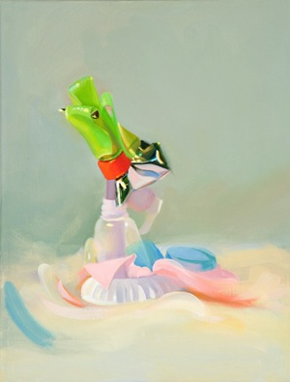
Amy Mahnick
Untitled, 2008
oil on canvas, 9” x 7”

Mahnick is an intimist in the tradition of Giorgio Morandi. Working from small models built from cartons and other household refuse, she invents fantastical sculptures and then captures them in her canvases.

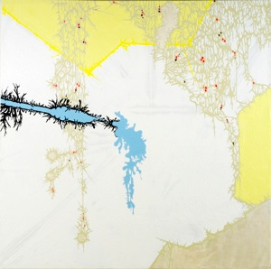
Julie Davidow
The New Strain #3, 2008
gesso, acrylic, latex enamel, and enamel paint on canvas, 48' x 48"

Davidow’s paintings and paint installations resemble nature forms mutating at the microscopic level, like crystals and lichen. Their drips and movements form diagrams of natural processes, normally hidden from view.

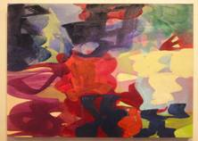
Melissa Meyer
Garden by the Sea I, 2006
oil on canvas, 22” x 22”

Meyer engages in a dynamic tension between pattern and chaos. Like threads in a tapestry, her looping skeins of color reflect her singular approach to grid-based painting.

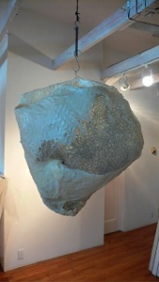
Madeline Denaro
New Form, 1999
Beeswax over gauze and chicken wire, 36” x 30” x 18”

Madeline Denaro’s work reveals a sensitivity to process and material textures that connects them to natural forms. Resembling a hive or nest, this work floats in space, casting shadows on the environment.
Courtesy the artist

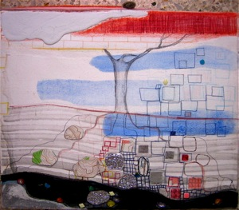
Theresa Hackett
After Life, 2001
Mixed Media on BFK paper on stretched linen

Theresa Hackett is a New York based artist who has passionately scoured the landscape tradition, rendering ethereal subjects such as sky and water with a variety of materials. Her painting work often moves beyond the borders of the canvas into mixed media installations involving felt and boxes.
Courtesy collection Michelle Weinberg

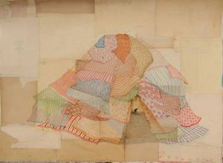
Mel Kadel
Grande Ole Fort, 2006
ink and collage on paper

Kadel’s illustrations depict hapless individuals bravely taming nightmarish emotions or overgrown body hair, puddles, overloaded shopping carts. In the tradition of Saul Steinberg and countless cartoonists, she finds humorous visual analogs for puns. The rough-hewn aspect of the surfaces she works on connects her to an outsider artist aesthetic.

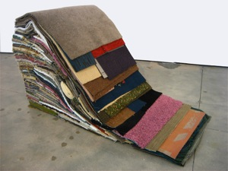
Kerry Phillips
Carpet Study (Antiform No. 4), 2007
Mobile carpet sculpture with carpet, pillows, wood, castors, 6' x 4' x 3'

Kerry Phillips is a South Florida artist who is developing a vocabulary for rendering memory visible using textiles. From carpet to knitting and felting, she pushes textile media to its utmost limits.

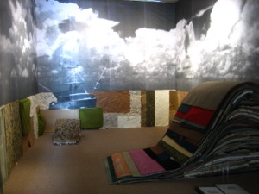
Kerry Phillips, installation view, Carpet Study, 2007
You can tell me . . . I'll make believe I'm listening, with George Sanchez
photo M. Weinberg

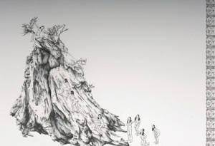
Su-En Wong, Big Rock
Graphite on paper, 30” x 44”

Wong’s replicated images of herself play with stereotypes of sexually vulnerable Asian women, both erotic and innocent. Her drawing technique is precise and channels centuries-old traditions of Asian landscape composition.

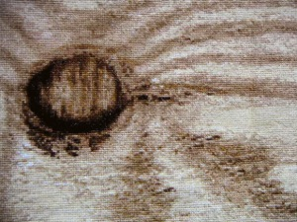
Frances Trombly
Plywood
cross-stitched fabric, 15 1/2” x 10”

Frances Trombly uses trompe-l’oeil effects in her work to recreate mundane, mass-produced objects, making labor-intensive pieces through weaving, embroidery, cross stitch, and crochet. Her work questions our attention to ordinary things.

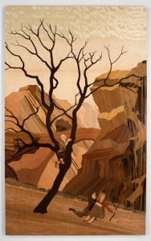
Alison Elizabeth Taylor
Redrock, 2006
wood inlay, polymer, 77” x 47”

Working in the intricate craft form of marquetry (inlaid wood veneer inlay and polymer), Taylor creates narrative works that depict contemporary scenes of tension and alienation. Her background as an indie comics artist.

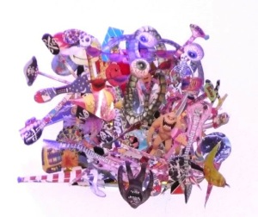
Pepe Mar
Untitled, 2004

Pepe Mar creates neo-dadaist explosions in paper. In this work, the monumental rage, distortion, and cacophony of commercial life is gathered like a tiny bouquet.

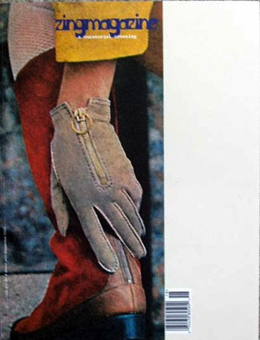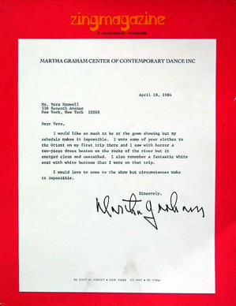
Devon Dikeou
ZING magazine

“zingmagazine came out of the idea that within certain disciplines, artistic and otherwise, various cross-references occur, both with individuals and the material of their particular interest. Rather than remaining isolated and apart, either through an unaware and uninformed (or aware and informed) malaise, there is a need to commingle arenas. The format of zingmagazine is comprised of rotating curatorial projects. Each curator is invited to create a context of their choosing for each issue. A myriad of different disciplines are explored in each issue from architecture, design, fiction, poetry, drawing, photography, video, music, fashion, as well as a special projects including books, posters, and CDs. Lack of parameters or limits is the impetus, with the idea that the creative impulse, within each of the curators/disciplines, will produce individual projects both of the curators and the participants.” - Devon Dikeou New York, New York 1995
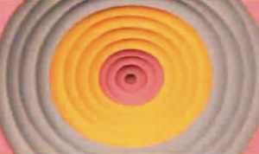
Jen Stark
Streaming Gradient, 2008
Animation on DVD (music by Eddie Alonzo), edition of 10

Using only colored paper, an x-acto knife and glue, this Miami artist creates mesmerizing sculptures of colorful vortices which she then animates. A subtle understanding of physical forces at play on our consciousness, her work hypnotizes.

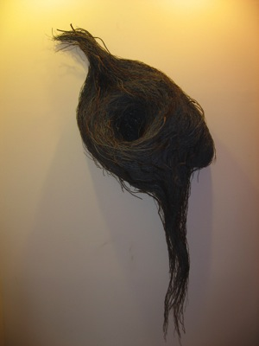
Claire Garrett
Departure
ficus benjamina fibers

Garrett trains natural raw material to do her bidding. A giant nest with trailing tendrils mimics a structure found in nature, and stylizes it.
Courtesy collection Teen Woon

OFFICE

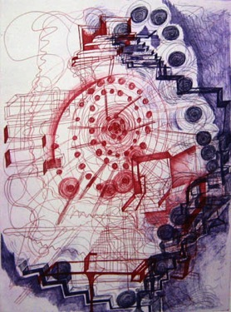
Joanne Greenbaum
Purple and Rose, 2007
color etching, 31” x 24”

Joanne Greenbaum practices a playful type of abstraction which treats the canvas like a construction site or a pinball machine, drawing the eye from one extreme to another, layering organic and geometric in an intuitive, unpredictable manner.

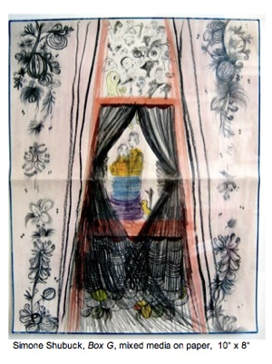
Simone Shubuck
Box G, 2003-04
mixed media on paper in box, 9” x 7”

Delicate, layered drawings on re-purposed stationery, Shubuck’s work is dense and emotional, drawing the viewer into scenes that are hermetic, decorative, nostalgic, feminine. She has been influenced by graffiti and outsider art movements in San Francisco.

HALLWAY

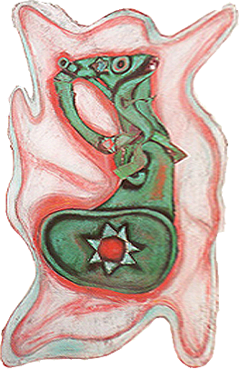

Elizabeth Murray
Rosy Glow, 1993
pastel, charcoal and ink on folded and collaged paper, 45” x 30 “ x 3”

Elizabeth Murray, who died in 2007, was a role model for countless female artists coming of age in the 1970s and beyond. Her blunt, cartoonish imagery and her signature thick, impasto paint handling on custom-shaped canvases were strikingly original. She was a painter’s painter, one who created a bold visual language out of the imagery of domestic mishaps, children’s shoes and the painter’s tools at hand. Her strides have influenced contemporary painters too numerous to mention here.

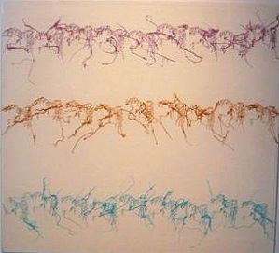
Ghada Amer
Untitled, 1997
embroidery and gel on canvas, 22” x 22”

Out of the delicate mass of skeins of threads on each canvas, the viewer is able to make out erotic figures in repeating patterns. Amer’s work expresses this female eroticism in the face of her Muslim upbringing. Ghada Amer: Love Has No End is on view at the Brooklyn Museum in New York.

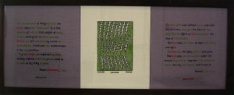
Elaine Reichek
Sampler: Non-existence, 2001

Reichek is a conceptual artist who uses embroidery. While an artist-in-residence at the Gardner Museum in Boston in 2001, Reichek began to develop a group of sixteen embroideries showing scenes from the biblical Book of Genesis and particularly the story of Adam and Eve. These updated “samplers” borrow images from artists ranging from Dürer and Michelangelo to Gauguin, Magritte, Barnett Newman, and Robert Smithson and quote sources from the Bible, Milton, Mary Shelley, Charles Darwin, Ray Bradbury, and film director David Cronenberg.

Diane Arrieta
I’m loving it, 2007

From a series of 20 illustrations printed on cheeseburger wrappers. It is a statement on childhood obesity and the fast food culture of this country. An artifact of contemporary Americana.

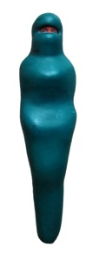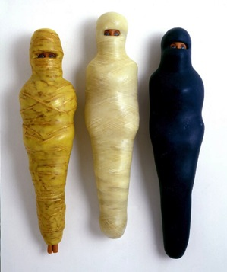
E.V. Day
Mummified Barbies, 2001
beeswax, twine

Simultaneously mocking the available sexuality of Barbie, and making a comment on the oppression of women in many cultures, New York-based artist E.V. Day has created works which puncture myths about femininity. Titles such as Bridal Supernova, Portable Cat Fight and Exploding Couture evince a humorous, take-no-prisoners approach to making sculpture in the 21st Century.

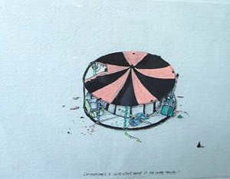
William Cordova
postcard, 4” x 6”

Cordova’s postcards from the urban experience depict carefully curated refuse, rejected consumer articles, abandoned vehicles, speakers and other flotsam from hip hop culture. Like talismans, his artifacts are imbued with a precious or sacred aura.

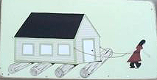
Clare Rojas
Untitled, 2003
gouache on panel, 7” x 13 1/2”

Rojas’ paintings and illustrations are an expression of a contemporary folklore in which women patiently endure trials, like the females in classic fairytales and fables. Borrowing the visual language and palette of quilting, gingham, wallpaper and upholstery, her works are at once accessible and speak of fantasy.

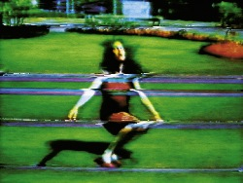
Pipilotti Rist
(Entlastungen) Pipilottis Fehler, 1988
video, 11:10 min, color, sound

Precisely edited to the start-stop rhythm of a martial beat and post-punk rock music, juxtaposing images of the artist collapsing to the ground with bursts of wildly scrambled electronic distortion. Produced while Rist was working at a professional video facility, the piece is an homage to the textures of TV’s gltisch and static. The music is partly provided by Les Reines Prochaines, Rist’s own band.
Courtesy collection of Debra and Dennis Scholl

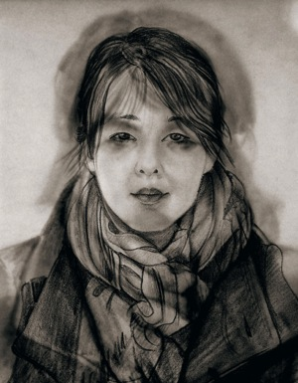
Nikki S. Lee
Layers, Prague, 2007
c-print, 92” x 74”
Korean-born artist infiltrates and documents herself meticulously adopting codes of dress, behavior, and living habits of other ethnic and social groups, playfully exposing the commonality of all humans.

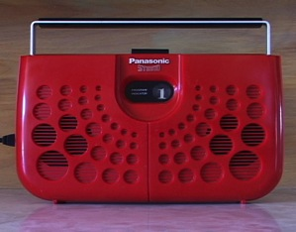
Cindy Bernard
In-A-Gadda-Da-Vida (White), video loop, 2006-08

From the series Learning to Listen, a work in progress featuring videos that archive artifacts from the analog universe. In addition to sound and video works, photographs document sites and objects from her personal iconography of listening: ham radio antennae, old gear, practice studios and defunct record stores.
Courtesy the artist

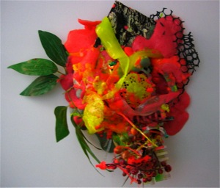
Cristina Lei-Rodriguez

Cristina Lei-Rodriguez fashions hybrid objects, part kitsch party regalia, part vegetable run amuck, all bathed in glittery syrupy resin. Her assisted natural forms suggest genetic modification and other unnatural alterations to nature. Her bouquet responds to Pepe Mar’s.

UPSTAIRS, LEFT TO RIGHT

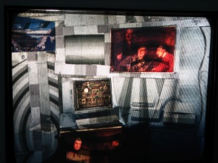
Kevin Arrow
Untitled [New Media Artist], 2008
Beseler Slide King 3610 and Polarized 4 x 5 transparency, motorized spinner.
Variable Dimensions

Arrow is a Miami artist who works in a unique manner, lovingly scavenging slide projectors from obscurity and obsolescence, and altering slide media to play in them. Nostalgic and visionary at the same time, his imagery makes comments on the obsession with social and mechanical progress.
Courtesy the artist

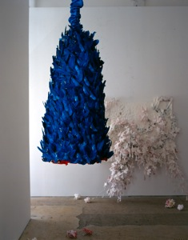
Petah Coyne
Untitled (Blue Birds), 2001
mixed media, 35” x 18”

Petah Coyne is a sculptor and installation artist who has worked in various mediums, from hanging sculptures made of mud, plaster, and wax. Her photographs are partially obscured subjects in motion. Her preference is to capture the essence of her subject, rather than its physical resemblance.

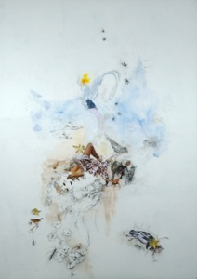
Rakel Bernie
Career Opportunities, 2008
collage, vellum,pencil, Indian ink,acrylic paint,magazines photographs
38” x 50”

Bernie is a Miami artist, originally from Argentina. Her works absorb feminine stereotypes cut and pasted from fashion magazines and merge them, via a series of incisions and surface alterations, with flora and fauna, suggesting a spiritual connection between woman and nature.
Courtesy the artist

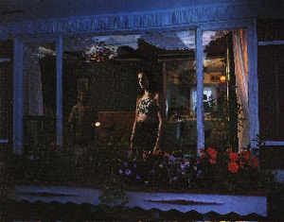
Gregory Crewdson
Untitled (Girl in Window) 1998
C-print

Highly influential to photographers of his generation and beyond, Crewdson borrows the elaborate staging and lighting techniques of the movie industry to construct disturbing narratives set in suburban neighborhoods and homes. In his work, nature often takes on a malevolent role, while human activity is detached and ambivalent.
Courtesy collection of Jane Hart

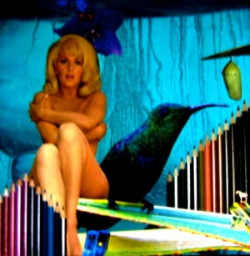
TJ Ahearn
Blue Monday 2007
collage on panel, 12 x 12"

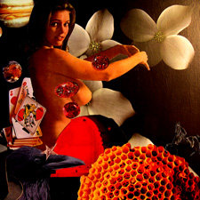
TJ Ahearn
Shade and Honey 2007
collage on panel, 12 x 12 "

TJ Ahearn is a pseudonym for curator and arts consultant Jane Hart, a South Florida artist. Her collage work compresses the seductive power of media imagery with soft pornographic visions of women. Using this vocabulary, she can make comments on the combination of consumer desire, violence and eroticism that bombards us daily.
Courtesy the artist

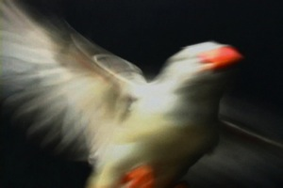
Teresa Diehl
Vuela, 2005
video 3:38 minutes

A slowed down, fragmented bird in flight, this work envelops the viewer in the midst of flight.

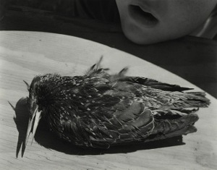
Andrea Modica
Fountain, CO, 2003
Platinum palladium print photograph

Modica works with the traditional photographic medium, employing large format 8” x 10” cameras and printing exquisitely rich platinum prints, a process perfected since the turn of the 20th Century. Her works capture moments of intensity gleaned from real life experience, which places her in the tradition of artists Diane Arbus and Paul Strand.

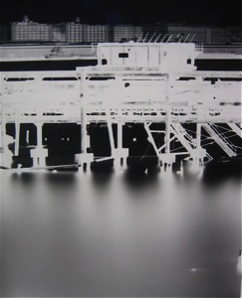
Vera Lutter
Pier and Water, Erie Basin, Red Hook, 2003
silver gelatin print, 24” x 20”

This work is one of a series of negatives, unique prints taken from direct exposure onto photographic paper hung inside rooms that Lutter transforms into camera obscuras. She is drawn to urban places bereft of human presence, revealing the architectural skeleton of these places.

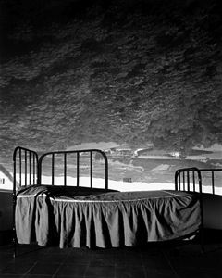
Abelardo Morell
Umbrian Landscape Over Bed, Umbertide, Italy, 2000
camera obscura

Morell takes an ordinary room - his living room, his son's bedroom, a hotel room -- and transforms it into a camera by placing black plastic over all of the windows, leaving a 3/8" hole through which the light passes. He then sets up his view camera in the room, points it at the opposite wall, opens the lens and lets the image appear on the film over the next eight hours. The result of his endeavor is a magical world which fuses outdoor elements with domestic scenes, allowing the viewer to see the existing reality outside the window. Morell has transformed many rooms into cameras, recording the Empire State Building inside a bedroom, Times Square onto the sterile walls of a Marriott hotel room, and a view of Brookline onto the walls and ceiling of his son's bedroom, as trees and buildings interact with toy dinosaurs.

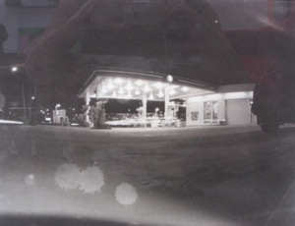
Courtney Johnson
Statewide Power Outage, 2008
platinum palladium print from pinhole camera, 11” x 14”

Johnson is a South Florida artist who transforms gritty consumer sites such as gas stations into ethereal cityscapes. From a series called No More Sitcoms, Johnson hand paints the photographic paper with platinum palladium solution, and exposes it for thirty minutes in a pinhole camera made of a holiday popcorn tin. Platinum palladium printing is one of the oldest, most expensive, most stable photographic processes.

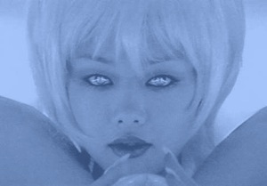
Mariko Mori
Miko No Inori, video

five-minute "Miko no Inori" [The Shaman’s Prayer] video Accompanied by the artist’s ambient sound composition "Kotoba wa Tokete" [Melting Language], the hypnotic piece features a tranced, silver-haired Mori in a silver vinyl bodysuit sporting shiny polythene pillow wings. She cradles a 12cm diameter crystal ball, slowly rolls the sphere from one hand to another, raises it to her face, kisses it gently, then tilts her head back, eyes closing in rapture as she lowers the ball to her pelvis. There is magic in the video, shot at the new Kansai Airport. For a few rare moments, the standardization and conformity that define people’s lives are displaced by the variety and possibility promised in this cute little cyborg’s virtual world. The fleeting feeling is that one has vicariously gotten in - to get out.
Courtesy collection of Debra and Dennis Scholl

at ART & CULTURE CENTER OF HOLLYWOOD

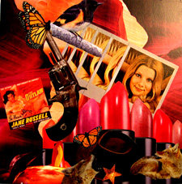
TJ Ahearn
Janie’s Got A Gun, 2007
collage on panel, 12” x 12”

TJ Ahearn is a pseudonym for curator and arts consultant Jane Hart, a South Florida artist. Her collage work compresses the seductive power of media imagery with soft pornographic visions of women. Using this vocabulary, she can make comments on the combination of consumer desire, violence and eroticism that bombards us daily.
Courtesy the artist

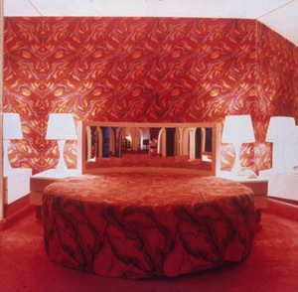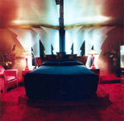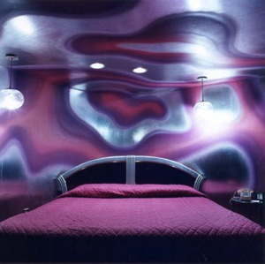
Lucinda Devlin
Paradise Stream Bedroom, Mt. Pocono, PA, 1979
Sheraton Valley Forge Hotel, Outer Limits Room, PA, 1990
Sheraton Valley Forge Hotel, Pulsations Room, PA, 1990
c-prints, 20” x 20”

Shot with a square format, wide angle lens camera, Devlin’s ouevre is an unblinking eye, documenting the discernible truth of pleasure hotel suites as evenly as she shoots lethal injection chambers throughout the United States. A profound statement on the artificiality of romantic environments and the sober, detached contemplation of capital punishment. Pleasure and pain.

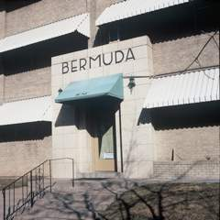
Devon Dikeou
Displaced Denver: Bermuda,” 2008 Cibachrome mounted on aluminum, 49”x49” Edition of 3, 2 AP
Courtesy the artist

Dikeou is a protean artist/publisher who uses photography to document moments of personal and cultural significance. The series of named buildings evokes a literary or narrative quality, each building the protagonist in a drama.

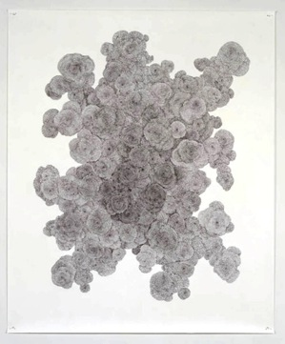
Tara Donovan
Untitled, 2002
ballpoint pen on paper, 72” x 59”

Donovan approaches everyday disposable materials and creates growth patterns that mimic natural forms like crystals. Massive accumulations of plastic drinking straws, Styrofoam cups or scotch tape take on colossal proportions.

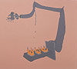
Inka Essenhigh
Yellow Turkeys, 1998
oil and enamel on canvas, 30” x 33”

“I think of my paintings as being about America: fake, fun, pop, violent but also quite attractive” Essenhigh says. Slick surfaces, shiny paint, pastel and TV colors, and an elastic approach to form, Essenhigh’s works’ curvilinear, narcotic distortions create a Disney-like effect, her subjects inhabiting a Fantasia-like dimension.

Click on images to enlarge

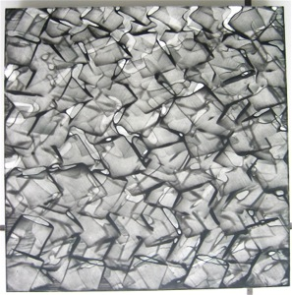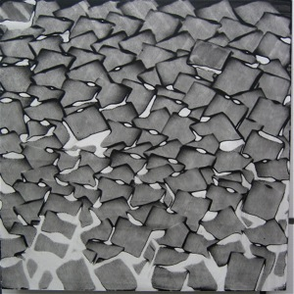
Lynne Golub Gelfman
Wet 1, 2, 3, 2008
acrylic on panel, 12” x 12” each

Lynne Golub Gelfman is a South Florida artist whose process of systematically layering canvases and panels with drips and daubs of color is well known. Simultaneously floating above the painted surface, and ingrained in its material, these works contain movement and flickering light generated from within.
Courtesy the artist

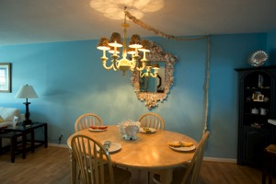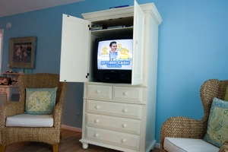
Francie Bishop Good
Del Ray Beach Interior, 2008
Cash, Del Ray Beach, FL, 2008
c prints, edition 1/5, 20” x 30”

Francie Bishop Good’s artistic practice straddles the color and gestural concerns of the trained painter with the detached eye in the tradition of American color photography. She pursues thematic series that focus on rites of passage of middle class characters in suburban environments.
Courtesy the artist

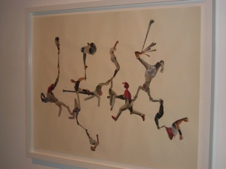
Quisqueya Henriquez
Untitled Baseball Players, 2007
collage, 37” x 48”

A conceptual artist working in diverse media, Henriquez breaks down barriers between high art and popular culture, especially the culture of the Dominican Republic where she resides. The mania for baseball among Dominicans is the inspiration for this work, one of a series of collages in which baseball players are abstracted and distorted to form acrobatic positions.

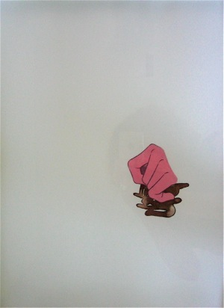
Arturo Herrera
collage on paper

Herrera’s collages slice and re-join body parts extracted from children’s coloring books. As Jessica Morgan has remarked, "Herrera's mix of cut, pasted and painted fairy-tale figures, coloring book images, advertisements and abstract, painterly marks creates a region of collision, a liminal zone in a state of constant penetration and transformation."

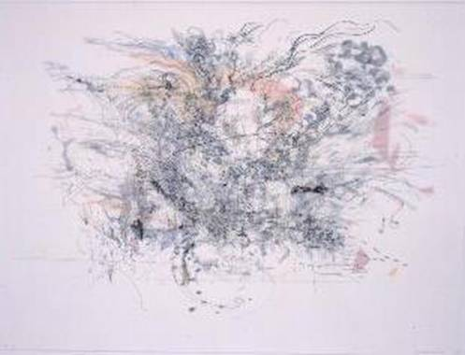
Julie Mehretu
Rogue Ascension, 2002 (edition)
Somerset satin white paper and denril vellum, 32” x 24 1/2 “

Mehretu employs a systematic approach, using projections to map large sprawling cityscapes on canvases, drawings and print editions. Floor plans from such disparate sources as the Roman Coliseum and international airports are densely layered.

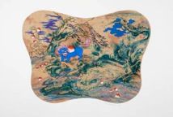
Jiha Moon
Nahan’s Forty Winks, 2007
Chin colle & lithography, 25” x 30”

Moon begins with traditional imagery and embellishes with gestural painting and a contemporary color sensibility.

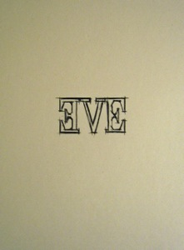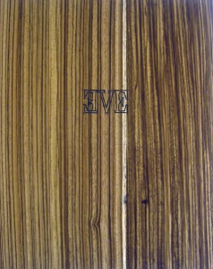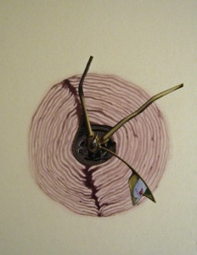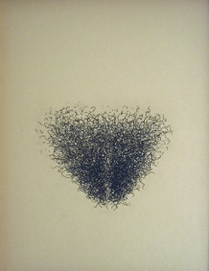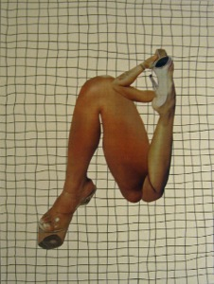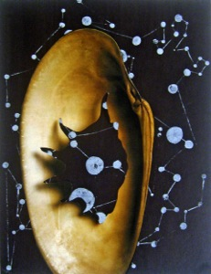
Wangechi Mutu
Eve, 2006
artist’s book

Mutu is a Kenyan born artist who uses collage to construct female figures to bring attention to the combination of eroticism and violence that is visited upon the female body.

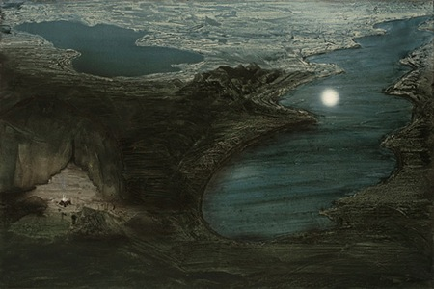
Julia Oschatz
Untitled (Elsheimer - The Flight into Egypt), 2008

This painting by Oschatz is one of a series of re-interpretations of famous works from art history in which she places a human/animal hybrid character of her own invention. Seen from a bird’s eye view, each painting’s landscape is re-created as if it is a film set.

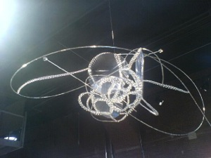
Alyson Shotz

Object in Space, 2006-07
glass beads, steel wire, cut plastic fresnel lens sheets, 9” x 13” x 28”

Alyson Shotz is known internationally for works of art that address space, light and perception. Her interests in environmental issues and topology. Lenses and optics make deliberate reference to vision.
Courtesy the artist

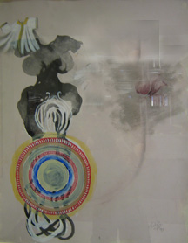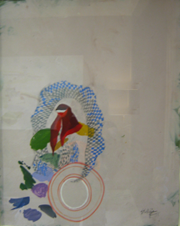
Shahzia Sikander
Wings, Veils and Dress II, 1997
vegetable and watercolor on clay and paper, 28” x 20”
Persistence of the Veiled Image, 1997
vegetable and watercolor on clay and paper, 28” x 22”

Originally from Pakistan, Shahzia Sikander has mastered the ancient art of Persian and Indian miniature painting, juxtaposing those classic forms with personal, stylized iconography. She has explored her imagery in new media techniques such as animation and wall-size paintings.

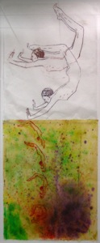
Nancy Spero
The Race, 1988
handprinting and printed collage paper,” x 20”

Nancy Spero is a New York artist who was one of the founder of A.I.R., the historic feminist collective gallery in SoHo in New York. Her career has spanned many decades, but her themes have never wavered: protest against physical and spiritual violence to women, re-valuing ancient and mythological and literary females throughout history. Her method of working involves such unique processes as hand-printing, and altered typewriters. Her works have often taken the form of tremendous, long manuscripts (a metaphor for history, the passing of time).

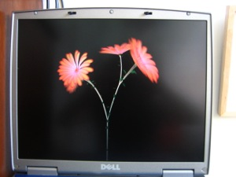
Jennifer Steinkamp
Dance Hall Girl 3, 2005
video

Jennifer Steinkamp is an installation artist who works with video and new media in order to explore ideas about architectural space, motion, and perception. A swaying hula-esque dance choreographed for African daisies, Dance Hall Girl 3 is a magical, hypnotic alteration of nature.

Frances Trombly
Publix / Target Receipts, and Random Receipts, 2008

Frances Trombly uses trompe-l’oeil effects in her work to recreate mundane, mass-produced objects, making labor-intensive pieces through weaving, embroidery, cross stitch, and crochet. Her work questions our attention to ordinary things.

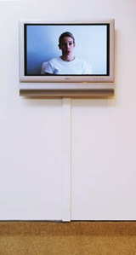
Rachel Perry Welty
Karaoke Wrong Number, 2001-2004
DVD, 7 minutes, Edition of 25

Welty, in a comic performance, retrieves and lip-syncs to the myriad wrong messages she received on her telephone answering machine. Again, the mistake, the humble household device, the hapless female discovering an ingenious marriage of the unexpected.

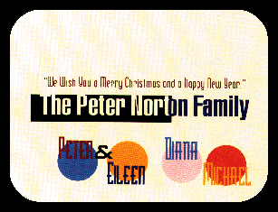
Pae White
Oblique Strategies, A More Universal Edition
Courtesy collection Jane Hart

Conceived originally as a holiday gift from collector Peter Norton and his family, this deck of limited edition playing cards designed by Los Angeles artist Pae White in collaboration with Brian Eno and others, engages the participant in a conceptual game.

